PIE Associate Application Instructions

  - Visit the PIE website to download the official application. This document is NOT the entire application. It is an additional instructional guide to applying to the PIE Associate position. Skip to the heading titled “Video Application” for instructions on the video portion of the PIE Associate application. The video portion of the application is due the same day as the written portion of the application: 11:59 PM, May 13, 2022.

PIE Associate Eligibility Requirements (see the PIE website)
PIE Associate candidates must:
- Be enrolled as a graduate student at FSU
- Have a strong interest in teaching
- Be in good academic standing and progress toward degree
- Have a TA appointment for the academic year
- Availability to attend mandatory monthly meetings, PIE workshops, etc.
- Prior graduate student teaching assistant (TA) experience at FSU (at least two semesters)
- Commitment for the academic year
- Availability to work approximately 5 hrs/week during the semester, plus training & Fall and Spring PIE Teaching Conference/TA Orientation
- Obtain written department support (letter of recommendation) and approval

Video Application
Submit a brief (3 to 5 minute) video introducing yourself to us and addressing the following points:
- What is your academic field/program?
- How long have you been a TA?
- What classes have you served as a TA for?
- What is your general philosophy on teaching/learning?
- What are your career and/or academic goals?
- Why do you want to be a PIE Teaching Associate?
- What skills/assets do you bring to PIE?
Tips for creating your video:
- Create an outline for what you would like to say beforehand—it does not have to be strictly scripted, but notes can be helpful to keep you on track.
- Adjust your lighting and background as needed to create a professional video.
- You can record a brief video using Zoom (linked to your FSU credentials). Here’s the link to the FSU Zoom login webpage: https://its.fsu.edu/zoom
- To record a video via Zoom, open a personal Zoom room. Use the recording option to record a video to the Zoom cloud. Once your video recording has processed, you can copy and paste the recording sharing link directly into the PIE Associate Application question that requests the video link.

Here are a few screenshots to guide your way through this process:

Log into Zoom via the Secure Zoom for faculty, staff, and students; use your FSU credentials:
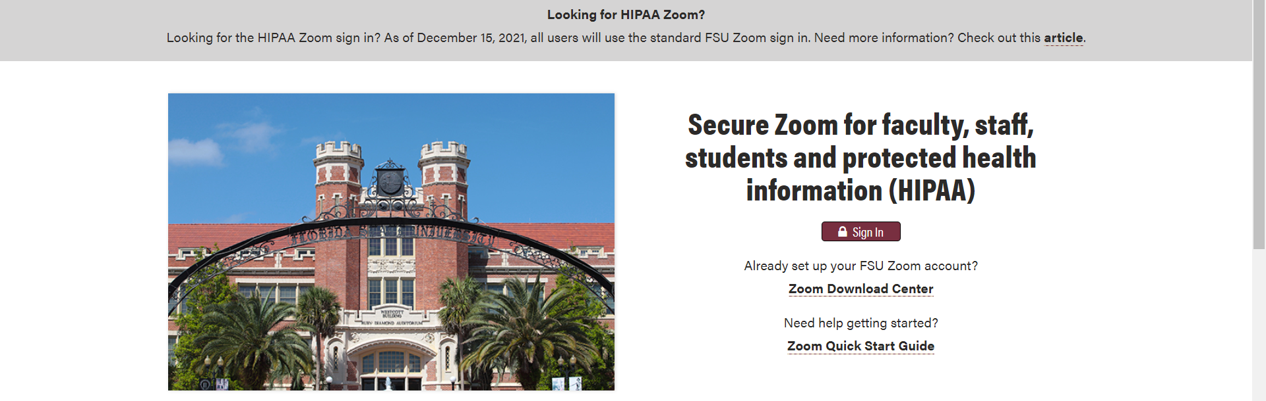
Ensure that your settings in Zoom are set to “Cloud Recording” Rather than “Local”
Ensure that “Allow cloud recording sharing” is toggled on:
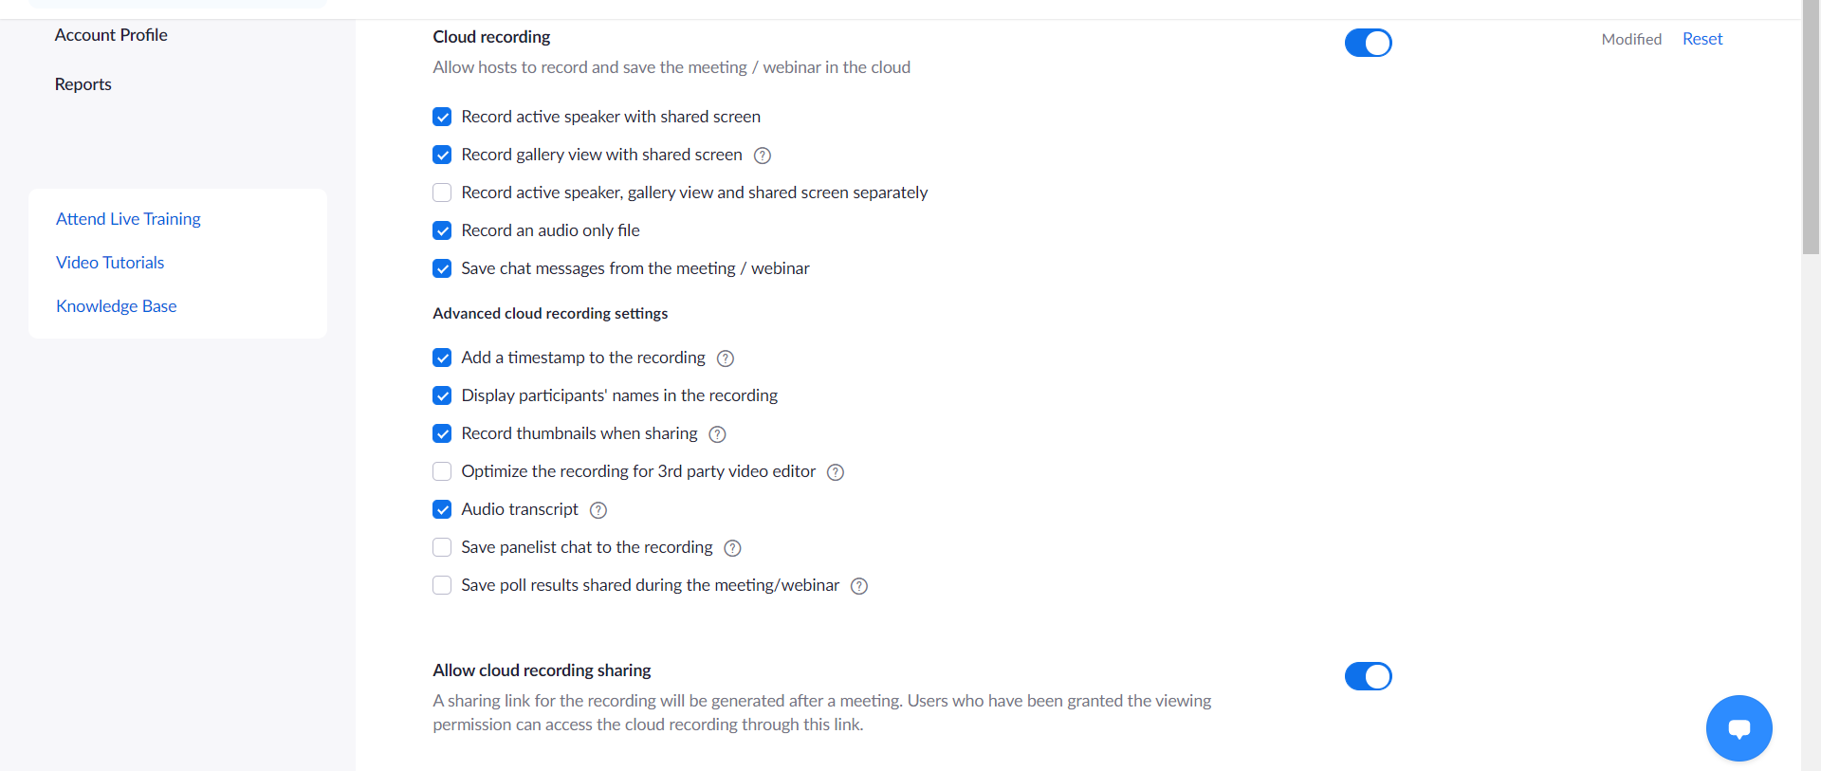
Go to “Meetings” and “Personal Room” on your Zoom account

Click “Start” to open a Zoom room

Once you are in your personal Zoom room, you can enable you camera and microphone and press the “Record to Cloud” button

When you are finished recording, click the “Stop” button. You will later get an email once your recording has processed containing the link for sharing your video with others. This link is what you will paste into the PIE Associate Application Qualtrics survey.

You will receive the following type of email from Zoom containing your recording link for sharing the recording with us:

