Designing and Facilitating the Online Classroom
A successful competitive science fair project takes planning and organization. Complete this page as soon as you learn of the assignment, post it in a prominent place, and use it as a guide for pacing and contents.

The Major Elements of Online Course Design:
Instructor  Roles |  | Course  Policies |  | Learning  Objectives |  | LMS  Shell
Element 1: Define Instructor Roles in the Online Class Space

 | Role Category | Write notes to indicate how you will fulfill each of these roles. When you have made a decision for a given role, you may check off the box on the left-hand side.
□ | Pedagogical  Role:  (Liu et al. 2005) | Use up-to-date, innovative information to build the materials, activities, and assessments in your course. Provide consistent feedback on content and illustrate concepts with real-world examples.
 | How I Will Fulfill This Role:
□ | Managerial Role  (Liu et al. 2005) | Take leadership in ensuring that the course is well-organized, materials are accessible, directions are clear, and communication among the online community is moderated.
 | How I Will Fulfill This Role
□ | Technical  Role  (Liu et al. 2005) | Select technologies that help students to achieve the learning goals of the course and provide thorough support for those technologies.
 | How I Will Fulfill This Role:
□ | Social  Role  (Liu et al. 2005) | Establish your online presence by fostering classroom communication, providing feedback to each learner, and maintaining availability to support students.
 | How I Will Fulfill This Role:
Element 2: Build University and Classroom Policies Into Your Course

University Policies are the broader Classroom policies are specific
guidelines at Florida State University to your course. These may be which apply across classes, directly affected by university
departments and individuals. policies, your department, or
your personal class management.

What are the practical differences?

University Policies (Mandated) | Class Policies (Personalized)
University Attendance Policy  - Excused/unexcused absences  - Accommodations  - First-day attendance | Class Attendance Policy  - Unexcused absence allowance  - Tardiness rules
Academic Honor Policy  - Academic Integrity  - Alleged allegations  - Student/staff rights and procedures | Grading Policy  - Grades for major assignments/activities  - Assignment revisions  - Extra credit
Americans with Disabilities Act  - Rights/accommodations for students with diverse needs  - Procedures for accommodating students with diverse needs  - Staff responsibilities/resources through SDRC | Technology Policy  - Laptop use rules  - Cell phone restrictions  - Class-specific technology guidelines
FERPA  - Student rights to academic privacy  - Staff responsibilities and procedures pertaining to student grade/course privacy rights  - Processes handled by the FSU Registrar | Netiquette Policy  - Online communication guidelines  - Civility  - Email guidelines
Sexual Harassment/Discrimination  - Student rights/procedures pertaining to harassment allegations  - Equal opportunity rights | Coursework Policy  - Rules for group work  - Rules for submitting past work  - Rules for seeking tutoring services

Resources | Notes on My Policies
Note: The university and class policies should be a foundation for your course syllabus
- Policy Information: https://fla.st/31NexEN
- Syllabus Policies: https://fla.st/37lOrdl

Element 3: Design Learning Objectives & Alignment

High-tier verbs ideal for final projects

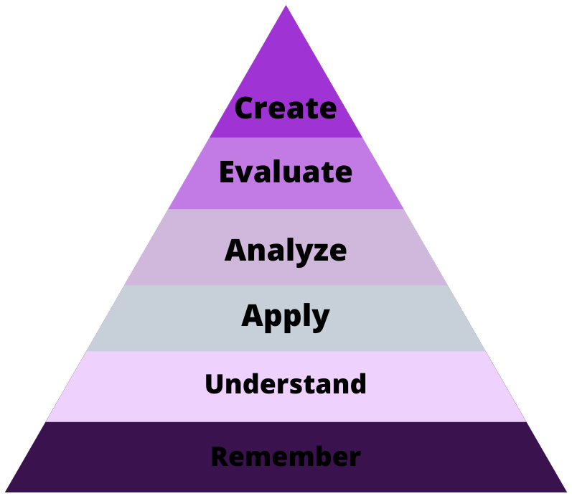
Low-tier verbs ideal for establishing foundations
Middle-tier verbs ideal for mid-semester activities/assessments

Step 1: Determine the hierarchy of learning outcomes in your course.
- The Bloom’s Taxonomy Pyramid can be used to determine what level of learning/cognition you wish to evaluate.

Step 2: Write measurable learning objectives.
- Learning objectives should use clear, observable verbs and specific criteria to ensure that you can accurately determine content mastery.

Step 3: Establish alignment—choose materials, activities, technologies, and assessments that facilitate learners’ successful completion of your learning objectives
- A given objective should be accompanied by materials, activities, technologies, and assessments that clearly coincide with that objective. For example, if you have a “Create” tier objective, the other elements of your course should help students to create a product.

Use the table below to write notes on your objectives and how you will achieve alignment.

Objective | Materials/Tech | Activities | Assessments

Element 4: Build Your Course Shell in the LMS (Canvas)

Course Shell Checklist
Use this list to verify that you have included these major components in your Learning Management System (LMS). You may write notes about your course in the right-hand column and check each component as you complete the list.

 | LMS Component | Overview | Resources | Notes
□ | Syllabus | You may import a syllabus or build one via Canvas design tools. Also consider attaching a Word document syllabus for accessibility purposes. | Syllabus Guide: https://fla.st/39vfeFg  Canvas Help: https://fla.st/3bvXFa1
□ | Course Introduction | Standards of high-quality course design state that your online course should include an instructor introduction and instructions for how to get started in the course. | QM Standard 1 on Course Intro: http://bit.ly/3bx2Hmx
□ | Modules | You may choose to build units, materials, and activities into the course by adding weekly modules. | Canvas Module Building: https://fla.st/2UMDVZZ
□ | Additional Apps/Tools | If you would like to include external Canvas-supported apps, you must request access to them via Canvas settings. | Canvas App Support: https://fla.st/2SlzsLV
□ | Institutional Resources | Standards of high-quality course design state that your online course should include a page with institutional resources for students such as IT, medical services, and external tech support. | QM Standard 7 on Student Support: http://bit.ly/3bx2Hmx
Content/Link References

Database Center for Life (n.d.). Scientist at desk [Online image]. Retrieved from

https://commons.wikimedia.org/wiki/File:201706_PC_silhouette.svg
- Image CC License: https://creativecommons.org/licenses/by/4.0/deed.en

External apps supported in FSU’s Canvas (n.d.). Retrieved from

https://support.canvas.fsu.edu/kb/article/772-external-apps-supported-in-fsus-canvas/

How do I add a syllabus to my site? (n.d.). Retrieved from

https://support.canvas.fsu.edu/kb/article/850-how-do-i-add-a-syllabus-to-my-site/

How to build your new Canvas course (n.d.). Retrieved from

https://support.canvas.fsu.edu/kb/article/781-how-to-build-your-new-canvas-course/

Liu, X., Bonk, C. J., Magjuka, R. J., Lee, S. H., & Su, B. (2005). Exploring four dimensions of online

instructor roles: A program level case study. Journal of Asynchronous Learning Networks, 9(4),

29-48. Retrieved from
https://pdfs.semanticscholar.org/75a1/b1d56196fcc9a75a41af1b13aabfc5423b16.pdf

Office of faculty development and advancement (n.d.). Retrieved from

https://fda.fsu.edu/leadership-toolkit/syllabus_preparation

Specific standards from the QM higher education rubric, sixth edition (n.d.). Retrieved from

https://www.qualitymatters.org/sites/default/files/PDFs/StandardsfromtheQMHigherEducatio

nRubric.pdf

Syllabus language (n.d.). Retrieved from https://facsenate.fsu.edu/Curriculum-Resources/syllabus-

language

Teaching policies (n.d.). Retrieved from

https://facsenate.fsu.edu/sites/g/files/upcbnu476/files/Media/Files/Curriculum/University%20

and%20FS%20Teaching%20Policies.pdf

