How to Prepare Your Electronic
2020-21 OTAA Teaching Portfolio

Table of Contents

- What to include in the portfolio 1
- Sample portfolio 2
- What tools you may need to prepare your portfolio and where to find them 8
- Combine all documents into a PDF file 9
- Where to submit your OTAA portfolio 11
- Optional Preparatory Workshops, Dates and Deadlines 11-12

- What to include in the portfolio:
There are EIGHT items that should be included in your portfolio. For a detailed explanation of each of the items, see the “2021 OTAA Guidelines”. Please refer to the following for examples or illustrations.

- Cover page (Limited to one page)
You may use the cover page provided on Page 2 for your OTAA portfolio and remember to put in the correct information about yourself.
- Current CV
You may refer to the sections listed in the example provided on Page 3 for your CV. There is no limit on how many pages you may have for your CV.
- Teaching Philosophy Statement (Limited to one page)
An example of a Teaching Philosophy Statement is provided on Page 4.
(4) Diversity Statement (Limited to one page)
- Course Narrative - Course 1:
Refer to Page 5 for elements to include in this statement.
- Course Narrative - Course 2:
Refer to Pages 5 and 6 for elements to include in this statement. To prepare for these two course narratives, you may need to get SPCI reports: Go to the following link, and follow the instructions under the “How will I access evaluation reports?” under the FAQ section: https://distance.fsu.edu/instructors/course-evaluations Get a scanned copy of your student evaluation /written comments: You may find a scanner at the basement of Strozier Library.

- Optional Appendices: Documents/items intended to support the assertions made in the course narratives. Nominees should include no more than five items. The nominee can, if desired, include student written comments scanned from the evaluation instrument or other types of student comments. These comments should be chosen carefully. Quality comments describe WHAT the nominee DOES in the classroom that helps students learn, NOT simply that he/she is the best TA. Repetitive comments should be avoided. The committee wants to know why the nominee stands out, and see evidence of continual growth as an educator!

- Eligibility Form (see Page 7)
You may download this form from the guidelines or our website at: https://pie.fsu.edu/outstanding-teaching-assistant-award/otaa-guidelines-and-process . Please print out this form and have it properly signed. Then, scan it to a PDF file and attach it to the portfolio as instructed in Session 3 (page 9) of this tutorial.

[OTAA Teaching Portfolio Example]

(First Name) (Last Name)
College of Education
Educational Psychology and Learning Systems

Degree Working Toward: Ph.D
Anticipated Graduation Date: May, 2021
Number of Students Taught in Spring 2020 – Fall 2020: 109
Teaching Position: A

[OTAA Teaching Portfolio Example]

Curriculum Vita
(First Name) (Last Name)
Address
Phone No.
Email

Education

Professional Experience

Publications

Presentations

Professional Development Activities

Service Activities

Awards

[OTAA Teaching Portfolio Example]

My Teaching Philosophy Statement
I believe that each child is a unique individual who needs a secure, caring, and stimulating atmosphere in which to grow and mature emotionally, intellectually, physically, and socially. It is my desire as an educator to help students meet their fullest potential in these areas by providing an environment that is safe, supports risk-taking, and invites the sharing of ideas. There are three elements that I believe are conducive to establishing such an environment, (1) the teacher acting as a guide, (2) allowing the child's natural curiosity to direct his/her learning, and (3) promoting respect for all things and all people.
When the teacher's role is to guide, providing access to information rather than acting as the primary source of information, the students' search for knowledge is met as they learn to find answers to their questions. For students to construct knowledge, they need the opportunity to discover for themselves and practice skills in authentic situations. Providing students access to hands-on activities and allowing adequate time and space to use materials that reinforce the lesson being studied creates an opportunity for individual discovery and construction of knowledge to occur.
SAMPLE
Equally important to self-discovery is having the opportunity to study things that are meaningful and relevant to one's life and interests. Developing a curriculum around student interests fosters intrinsic motivation and stimulates the passion to learn. One way to take learning in a direction relevant to student interest is to invite student dialogue about the lessons and units of study. Given the opportunity for input, students generate ideas and set goals that make for much richer activities than I could have created or imagined myself. When students have ownership in the curriculum, they are motivated to work hard and master the skills necessary to reach their goals.
Helping students to develop a deep love and respect for themselves, others, and their environment occurs through an open sharing of ideas and a judicious approach to discipline. When the voice of each student is heard, an environment evolves where students feel free to express themselves. Class meetings are one way to encourage such dialogue. I believe children have greater respect for their teachers, their peers, and the lessons presented when they feel safe and sure about what is expected of them. In setting fair and consistent rules initially and stating the importance of every activity, students are shown respect for their presence and time. In turn they learn to respect themselves, others, and their environment.
For myself, teaching provides an opportunity for continual learning and growth. I feel there is a need for compassionate, strong, and dedicated individuals who are excited about working with children. In our competitive society it is important for students to not only receive a solid education, but to work with someone who is aware of and sensitive to their individual needs. I am such a person and will always strive to be the best educator that I can be.
[OTAA Teaching Portfolio Example]

Course Narrative 1: EDP 5300 Course Title
Course Taught in Summer 2020, Number of Students: 30
Teaching Responsibilities:

Approach to Teaching and Learning:

Innovative Teaching Practices:

Outcomes:

Reflective Statement/Plan for Growth:

[OTAA Teaching Portfolio Example]

Course Narrative 2: EDP 5301 Course Title
Course Taught in Fall 2020, Number of Students: 20
Teaching Responsibilities:

Approach to Teaching and Learning:

Innovative Teaching Practices:

Outcomes:

Reflective Statement/Plan for Growth:

OUTSTANDING TEACHING ASSISTANT AWARD (OTAA)
ELIGIBILITY FORM
The undersigned has been nominated for the Outstanding Teaching Assistant Award. To qualify for this award, the nominee must have served as an FSU teaching assistant (TA) at FSU for at least two completed semesters, one of which must have been during the Spring 2020, Summer 2020, or Fall 2020 time period, and nominee also must be a current FSU graduate student in good academic standing.

Please check ALL that apply:
Current Degree-seeking student at FSU (OR FAMU-FSU College of Engineering)
Currently in Good Academic Standing
NOTE: to be eligible to apply for this year’s award, nominee must have been appointed/served as a TA for at least one semester during 2020 (spring 2020, summer 2020, or fall 2020)

Served as a TA for Spring 2020 at FSU
Served as a TA for Summer 2020 at FSU
Served as a TA for Fall 2020 at FSU
Served as a TA for at least 1 other semester at FSU (if did not serve as a TA for 2 of above-mentioned semesters in 2020)
Not a previous OTAA winner
Not a current PIE Teaching Associate
The nominee and faculty supervisor must both verify that the nominee fulfills the above requirements to qualify for the Outstanding Teaching Assistant Award.

Name of Nominee [PLEASE PRINT]:______________________________________________________
First Name Last Name

Name of Supervisor [PLEASE PRINT]:______________________________________________________
First Name Last Name

_________________________________ __________________________________
Signature of Nominee Signature of Supervisor

_______________ _____________

Date Date
- What tools you may need to prepare your portfolio and where to find them:

- Software for combining files into a pdf document. Some options are:
- Adobe Acrobat Professional version: Where can you find it: In the computers in any FSU library or in some department’s computer lab. See Section 3 of this tutorial for how to use this software to work on your portfolio.
- https://smallpdf.com/merge-pdf : a free online tool for creating and editing pdf
- A scanner: You can find a scanner in the basement of Strozier Library. If you don’t know how to use a scanner you find in the library, you can ask a librarian for help.
Files you may need to scan include: The signed Eligibility Form, Course evaluations that are not in electronic format, student written comments on your course evaluations, and other supporting materials you wish to include.

- Combine all the documents into a PDF file. (Instructions for using Adobe)
- Open the Adobe Acrobat Professional software, and go to “Tools” and select “Create PDF”

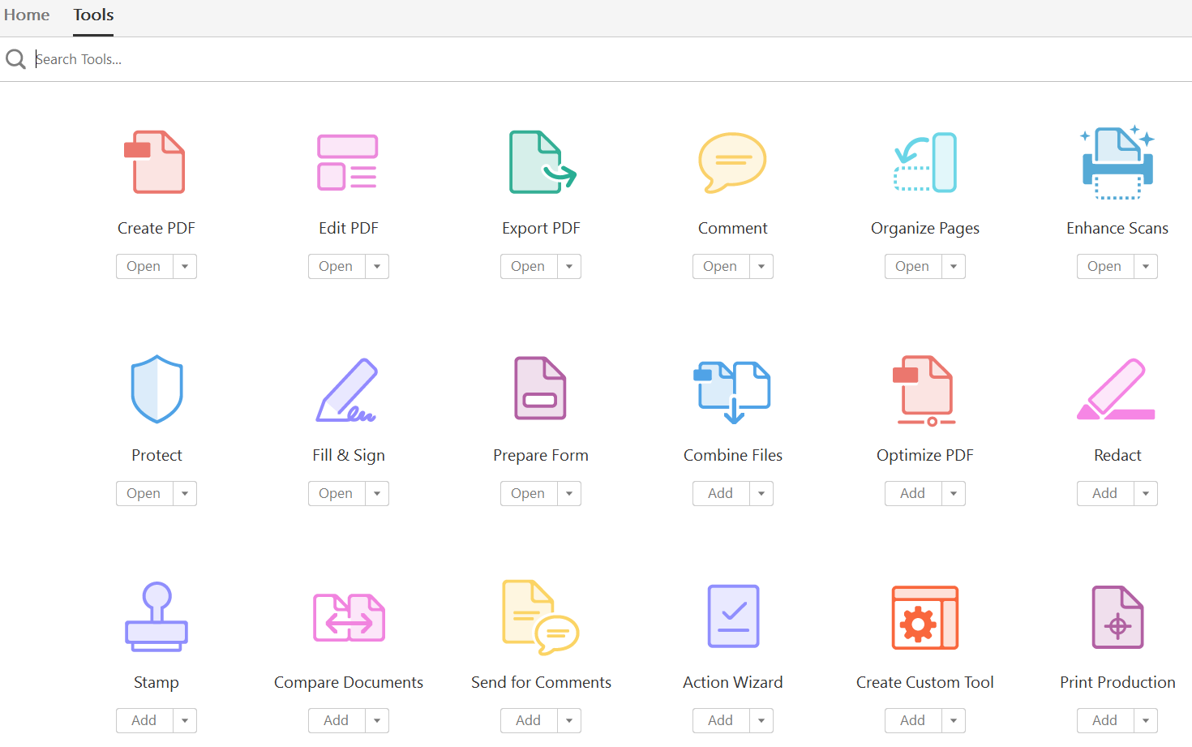

- On the next page, select Multiple Files, and select Combine Files. Then lick Next.
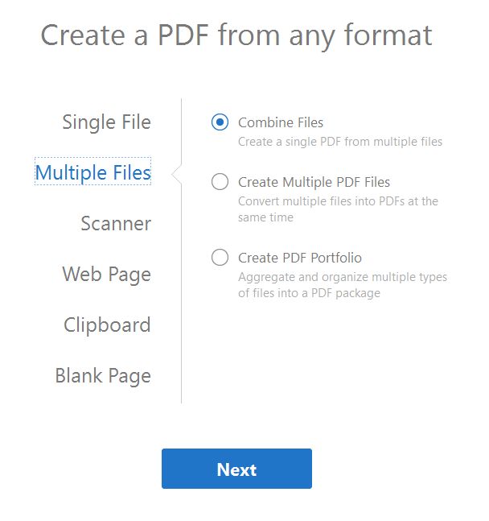
- On the Add Files… pop-up window, find the location where you saved your documents, and select all of them at one time (press shift while selecting multiple files).
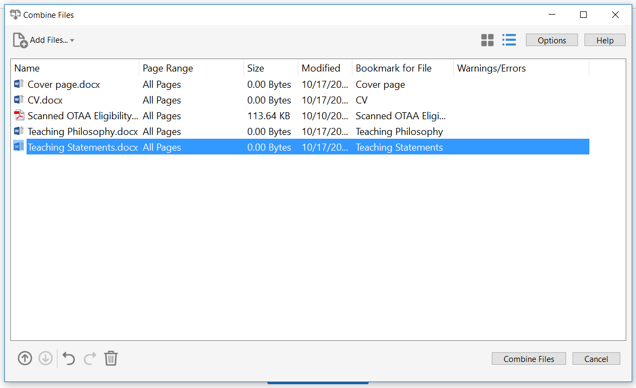

- You may adjust the order of the document on the list by clicking on a file name, and using the Move Up or Move Down arrows at the bottom to move the selected file to the place you want it to be.
- The sequence of the documents should be:
- Cover page
- CV
- Teaching Philosophy Statement
- Diversity Statement
- Course Narrative – Course 1
- Supporting materials for Narrative 1 (if applicable)
- Course Narrative – Course 2
- Supporting materials for Narrative 2 (if applicable)
- Appendices (optional)
- Signed Eligibility Form (please have your department check all eligibility requirements carefully and have your department sign it)
- When all the documents are in the list and in the above sequence, click on Combine files, and name the file as: FirstName LastName_portfolio.pdf (e.g. Mike Parsons_portfolio.pdf).

- Where to submit your OTAA portfolio?
Your portfolio must be submitted electronically to our OTAA 2020-2021 Canvas site as a single PDF document. You can also find additional instructions, clarifications, materials, and resources for the portfolio creation process at this site. Please follow the steps below:
- Self-enroll into the OTAA 2020-2021 Canvas site via this link: https://canvas.fsu.edu/enroll/H3DBJ7
- Read the “Start Here” page for important eligibility reminders and dates.
- Read all instructions and requirements for portfolio content. Please note that the recommendation letter is mandatory and separate from your original nomination letter. Read the instructions for requesting/submitting recommendation letters carefully.
- Consult additional resources in the site as necessary.
- When your portfolio is complete, submit it as a PDF via the assignment link titled “OTAA 2020-2021 Portfolio” by 11:59 PM, February 23, 2021.

Optional Preparatory Workshops, Dates, and Deadlines:

- How to Create a Teaching Portfolio
Friday, Feb. 5th, 2021, 10:30a.m. – 12:00p.m. (will be held remotely via Zoom)
Description: Creating a teaching portfolio is an important way to illustrate the strategies and techniques you use to help support and encourage student learning. It also gives you the opportunity to reflect on your teaching and ways to improve for the future. Not only is this a helpful exercise, but may be a requirement when applying for future employment. This workshop will give you examples and time to discuss how to assemble an electronic teaching portfolio. Requirements for the submission of teaching portfolios from nominees of FSU’s Outstanding Teaching Assistant Award (OTAA) will also be addressed.
Registration: https://bit.ly/REGIS_0205

- Creating a Diversity Statement
Monday, Feb. 8th, 2021, 1:00pm-2:30pm (will be held remotely via Zoom)
Description: It has recently become commonplace for faculty positions (amongst others) to include a Diversity Statement in the required application materials. A Diversity Statement requested by faculty positions expects a description of how the applicant will promote diversity in their teaching and research. In this workshop, we will discuss how to personalize and construct a Diversity Statement that considers teaching, research, and other aspects of one’s experience.
Registration: https://bit.ly/REGIS_0208
*These workshops are NOT REQUIRED. They are OPTIONAL. The purpose is to cover general guidelines for assembling a teaching portfolio, and a diversity statement, and to answer any questions that you may have.
See more workshop information, and registration link here: http://pie.fsu.edu/coffee-hour-teaching-workshop-series
- Deadline for submitting your OTAA portfolio to the Canvas site:
All portfolios must be submitted electronically to the OTAA 2020-2021 Canvas site by 11:59p.m. on Sunday, February 23, 2021. *Late or incomplete teaching portfolios will not be accepted. This means that ALL supporting materials (including your one letter of recommendation from a faculty or staff member, which is NOT the same document as your nomination letter – see the “2020-2021 OTAA Guidelines” for complete details) MUST also be received by PIE by this deadline.
Please direct any questions or concerns to pie-info@fsu.edu.

