FSU Zoom Quick-Start Guide
By Caity Kelly

Step 1
Go to the following link: https://its.fsu.edu/zoom. You will be taken to the page featured below.
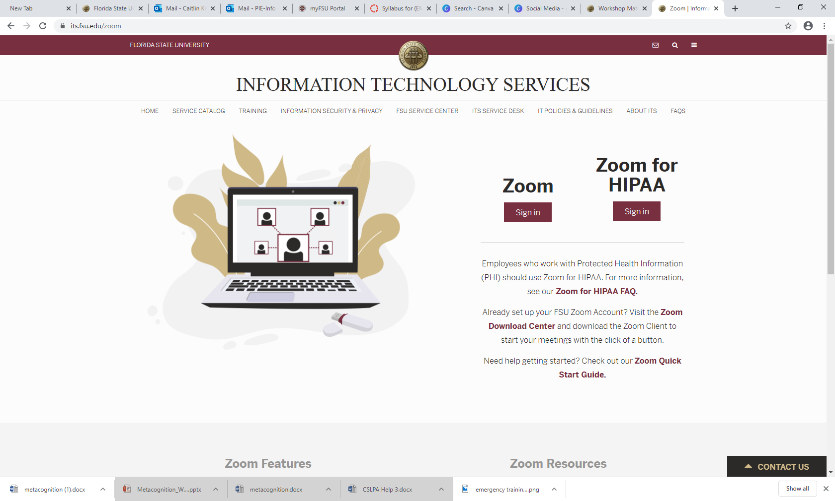

Step 2
Select the option that reads “Zoom Sign in” to the left of the “Zoom for HIPAA Sign in” button.

Step 3
If you are not already signed in to the FSU system, you will be prompted to enter your FSU ID and password. If you are already signed in to the FSU system, you will be automatically be brought to the Zoom page featured below (personal information redacted).
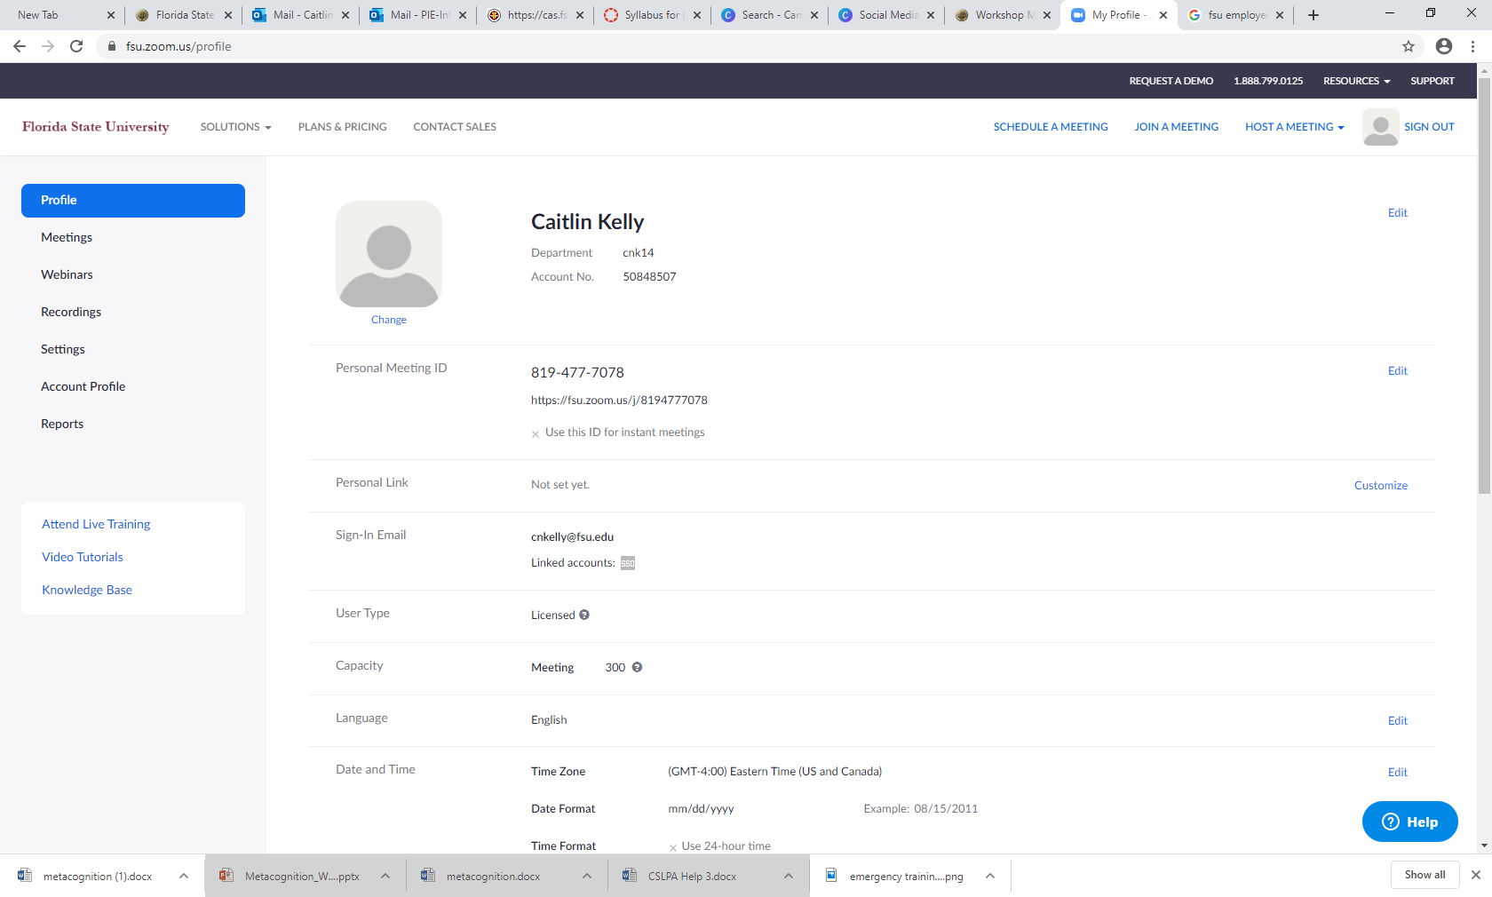

Step 4:
Depending on how you would like to set up a meeting, you have several options:
- Option A: Click “Schedule A Meeting” in the upper right corner of the screen.

  - Option A Step 1: Enter your meeting topic and an optional description.

  - Option A Step 2: Enter your meeting time and duration information.

  - Option A Step 3: Enter information about required meeting registration, meeting IDs/optional passwords for joining the meeting, and audio/video/hosting options.

  - Option A Step 4: Once you have saved your meeting settings, you will be given a Zoom link which you can send to your attendees via email.

- Option B: Click “Join a Meeting” in the upper right corner of the screen.

  - Option B Step 1: You will be prompted to enter a meeting ID or personal link name, which you should have received via an email invitation from the meeting host.

- Option C: Click “Host a Meeting” in the upper right corner of a screen. This will allow you to begin hosting a meeting immediately. Select your video and screen sharing preferences to get started.

Step 5
No matter which option you choose, you will be brought to the screen below. You can begin/join the Zoom meeting from your Browser or from the Zoom desktop app if you have it installed.

Step 6
Adjust your computer audio, video, and microphone settings as needed to participate in the Zoom meeting. Some browsers and computers automatically block these capabilities so you may need to adjust your permission settings. It is recommended that you load the Zoom meeting prior to the meeting time to ensure that your settings are properly adjusted. Keep in mind that many FSU desktop computers will not easily run audio/video for Zoom—laptops are a more reliable alternative.

Additional Notes on Zoom
- You can manage meeting participants and mute users if necessary—some users may forget to mute their microphones when they are not actively speaking, which can cause distracting ambient noise.
- You can share your screen to display things like Canvas or presentations via the “Share Screen” option.

- You can record Zoom meetings; however, it is recommended that you gain your participants’ permission before doing so.

- The chat function allows all meeting participants to send messages via text to the whole group or to individual participants. It is recommended that you monitor this chat as you are hosting a Zoom meeting.
- If users do not have computer access or are experiencing technical difficulties, they may choose to call in to the meeting via phone.

