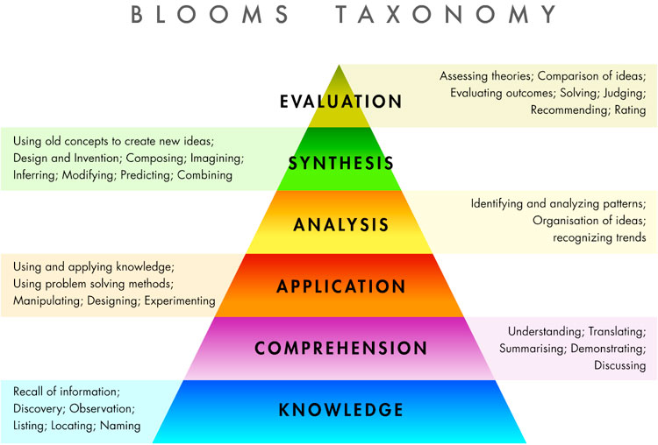

Activity: Think of a course objective for a course that you have already taught, or will teach. Come up with at least one new activity that you can utilize in your classroom in order to encourage higher level critical thinking in this course objective.

