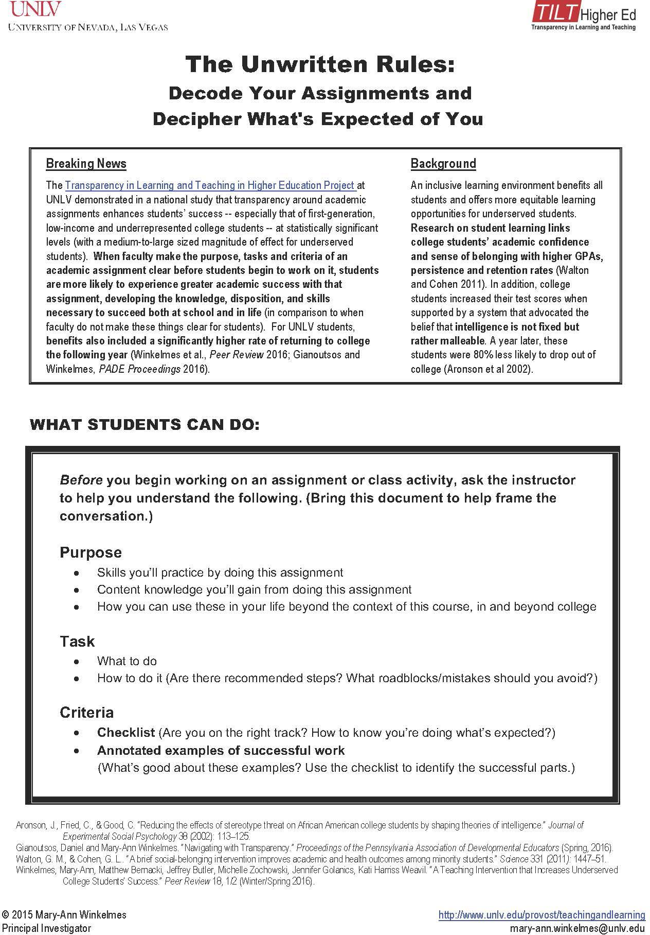
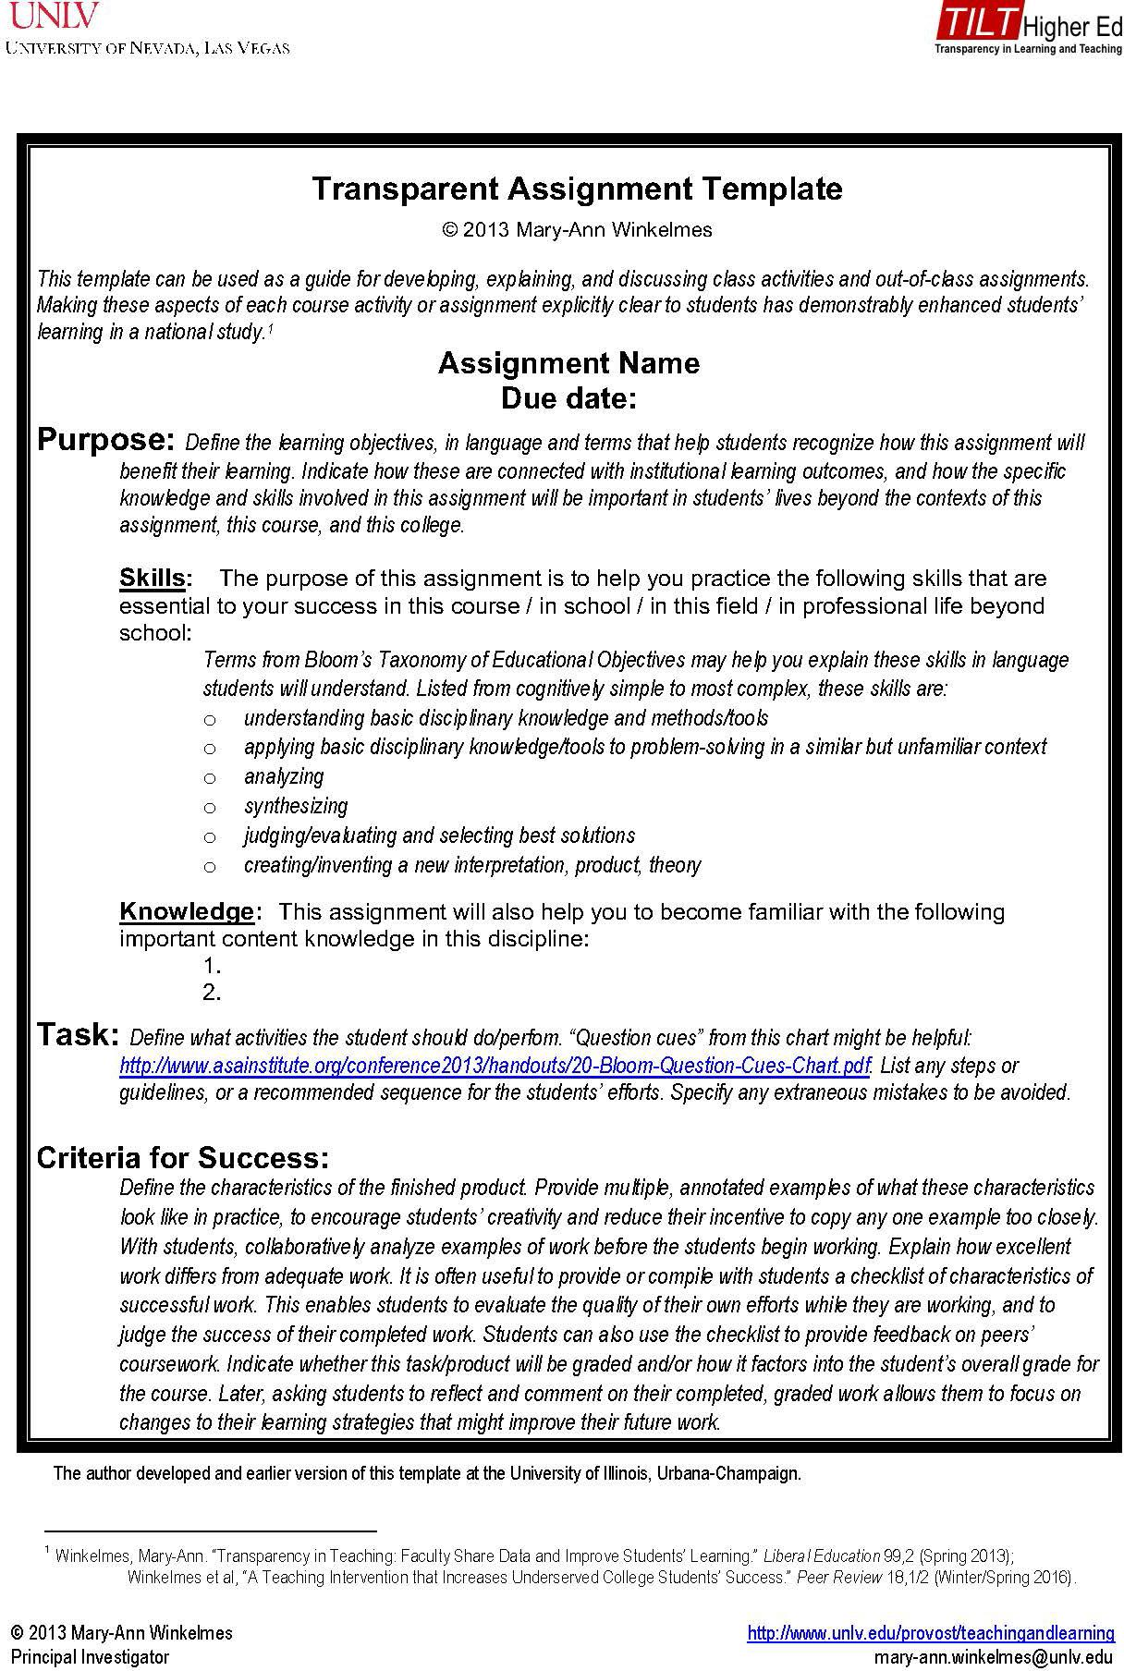
Transparent Assignment Template
Assignment Name:
Due Date:
Purpose:
Skills:

Knowledge:

Task:

Criteria for Success:

